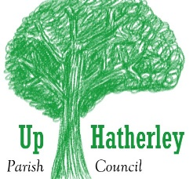
Up Hatherley Parish Council
Community Grant Scheme Application Form*
Name of applicant
Address
Telephone
Email
Name of organisation (if any)
Are you/is your organisation based in Up Hatherley?
Describe your organisation e.g. Registered Charity (please give your registered Charity number), voluntary group, service provider.
What is your job in the organisation?
Describe, in detail, what your project** is for
How do you know there is a need for your project?
What is the gross cost of your project (only include VAT if you are unable to recover it)?
What contribution to this are you asking the Parish Council to provide?
If you are seeking running costs, please indicate whether there is an intention to access other income streams to cover these costs in future years.
What would be the direct benefit to the people of Up Hatherley?
Is your project of particular benefit to any particular group of people?
Would your project benefit the whole Parish or part of the Parish (please describe)?
Is there any other information that you think would help the Council decide whether to support your application?

If you need to talk to someone before you send off this form, please phone 01242 527770 / 07403582 or email the Clerk at Clerk@uhpc.org.uk
I confirm that I have read, understood and agree to abide by the Rules of the Community Grant Scheme
Signed
Date

Please return your completed form by email to: clerk@uhpc.org.uk
* Continue on a separate sheet if necessary
** An application may be made for a specific, one-off purchase, piece of work or contribution towards running costs of a project; OR towards one element of a bigger project which the Council may support again, in another year.
For use by Up Hatherley Parish Council
Application Form received (date)
Confirm that the form is complete (initials)
Considered at the Council meeting (date)
Council’s decision
Grant offered (date)
Grant accepted/rejected (date)
Grant paid (date)
Other

